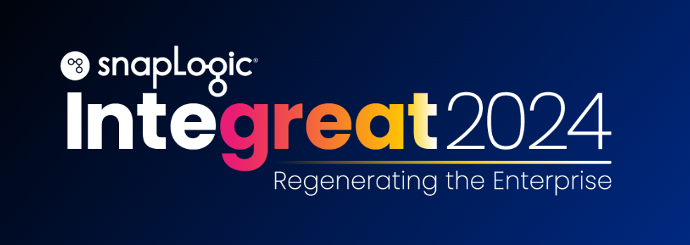

Hello,

I’m reaching out because I would like to attend SnapLogic’s Integreat Tour: Regenerating the Enterprise in San Francisco, CA on October 23, 2024..

SnapLogic’s Integreat Tour is an exclusive event that brings together professionals and industry leaders to share their thoughts and insights on the future of integration with generative AI.

Some of the topics I’m interested in learning more about at the Integreat Tour include:

- Hearing from industry leaders and experts on how they are transforming faster with Generative AI
- Participate in hands-on workshops to better understand generative integration
- Earn SnapLogic certifications

Registration is free and includes all of the items listed above.

Thank you for considering allowing me to attend this professional development opportunity.

Kind regards,

